Pinkvilla Architecture

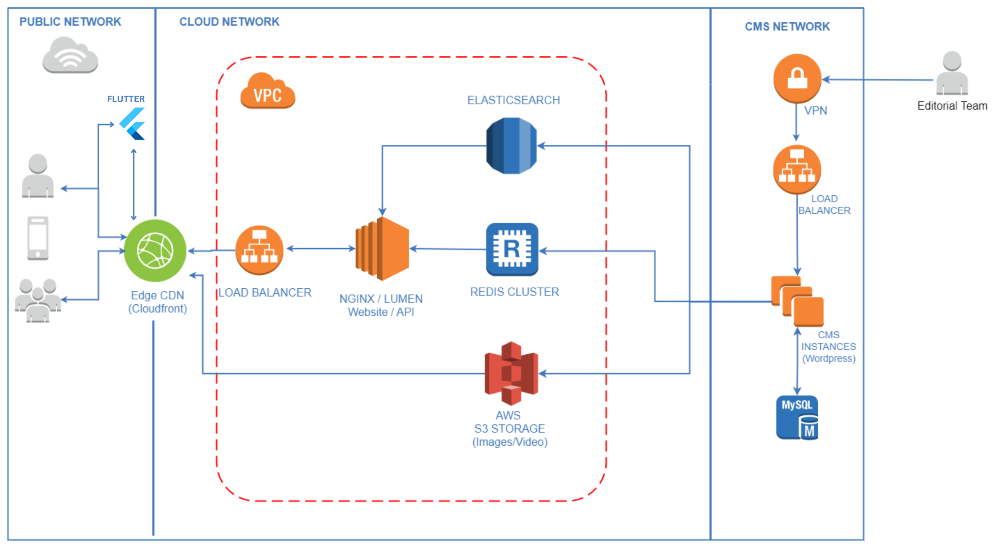

Website Architecture
1. Overview of Website Architecture
- Architecture Type: Headless CMS, Web Application, Microservices-based architecture for scalability.
- Tech Stack:
  - Frontend:.Laravel Lumen Framework, responsive UI
  - Backend: Wordpress, Apache Solr, Nginx Proxy Server
- Infrastructure: Hosted on Amazon Web Services (AWS) for high performance and reliability.
- Content Management System (CMS): WordPress-based with custom plugins for editorial workflows.

2. Frontend (Client-Side)
- Tech Stack:
  - JS, HTMl, CSS
- Key Features:
  - Fast-loading content pages optimized for SEO.
  - Dynamic content feed: Articles, videos, and images.
  - Responsive design ensures seamless experience across desktop, tablet, and mobile.
- UI/UX: Optimized for accessibility, quick navigation, and performance.

3. Backend (Server-Side)
- Tech Stack:
  - Wordpress, PHP, Laravel Lumen Framework.
  - RESTful APIs serving dynamic content to frontend.
- Database:
  - Primary: AWS RDS (MySQL) for structured data storage.
  - Caching: Apache Solr, Redis for fast retrieval of frequently accessed content.
- Content Delivery: AWS CloudFront (CDN) for global distribution with minimal latency.

4. Content Management System (CMS)
- WordPress-based backend for editorial workflow.
- Custom plugins and integrations for:
  - Scheduled publishing.
  - Media asset management.
- Integration with APIs for dynamic delivery to the frontend.

5. Media and Asset Management
- Image and Video Storage: AWS S3 for scalable storage of assets.
- Content Optimization: Nginx Image caching, and serving the responsive Image for faster load times.
- Video Hosting: YouTube and embedded players for video content streaming.

6. Security and Authentication
- Security Measures:
  - HTTPS/SSL for encrypted data transmission.
  - Instance level Security (Security Groups), Network Level Security (NACL).
- Authentication:
  - OAuth 2.0 for secure user login.
  - Session management and cookies for personalization.

7. Scalability and Uptime
- Load Balancing: AWS Elastic Load Balancer (ELB) for handling traffic spikes.
- Caching: Redis and Cloudfront CDN for faster delivery and load optimization.
- Redundancy: Multi-region deployment for high availability, Backup service enabled and disaster recovery.
- Scalability: It can be scaled by increasing the frontend Webservers.

8. Analytics and Monitoring
- Performance Monitoring:
  - Google Lighthouse for forntend and Synthetic Canaries for frontend and backend health.
  - AWS CloudWatch for server performance and logs.
- User Analytics:
  - Google Analytics 4 (GA4) for traffic and behavior tracking.

9. Ad Tech and Integrations
- Ad Integrations:
  - Google AdSense and third-party ad networks for monetization.
  - Header bidding setup for optimal ad performance.
- Third-Party Tools:
  - Social media integrations (Facebook, Instagram, X, Pinterest).
  - Content syndication partnerships (Google News, Flipboard, etc.).

10. Key Features and Functionalities
- SEO Optimized: Server-side rendering (SSR) with PHP.
- Real-Time Content Updates: Instant publishing via CMS.
- Performance Optimization: Lazy loading, Nginx image compression, and caching.

App Architecture

1. Overview of App Architecture
- Architecture Type: Micro services.
- Framework: Built using Flutter, Dart (cross-platform compatibility for iOS and Android).
- Backend: RESTful APIs powered by CDN built in PHP.
- Infrastructure: App is hosted on PlayStore, App Store and APIs are hosted on Amazon Web Services (AWS).

2. Frontend (Client-Side)
- Tech Stack:
  - Flutter for cross-platform UI/UX development.
- Key Features:
  - Content Feed: Dynamically loads articles, videos, and images.
  - Offline Mode: Content caching for limited connectivity.
  - Notifications: Real-time push notifications via Firebase Cloud Messaging (FCM).
- UI/UX: Optimized for performance, responsive design, and smooth navigation.

3. Backend (Server-Side)
- Tech Stack:
  - Flutter, Dart
- APIs: RESTful APIs to fetch, serve, and manage content across devices.
- Data Management:
  - Rest APIs, Firebase
  - Redis for caching frequently accessed content to improve response times.
- Content Delivery: Integrated with AWS CloudFront (CDN) for global content delivery.

4. Media and Asset Management
- Image & Video Storage: AWS S3 for scalable media storage.
- Content Compression: Optimized for faster load times.
- Streaming: YouTube embeds for videos to ensure scalability.

5. Security and Authentication
- User Authentication:
  - OAuth 2.0 for secure user logins.
  - Firebase Authentication for seamless third-party sign-ins (Google, Facebook).
- Data Security:
  - End-to-end encryption for data transfers (SSL).
  - Regular security audits and compliance checks.

6. Analytics and Monitoring
- Performance Monitoring:
  - Firebase Crashlytics for real-time error detection.
- User Analytics:
  - Google Analytics for tracking user behavior.

7. Scalability and Uptime
- Redundancy: Multi-region deployment for minimal downtime.
- Caching: Redis for fast API responses and content delivery.

8. Notifications and Engagement
- Push Notifications: Powered by Firebase Cloud Messaging (FCM).

9. Key Integrations
- Social Platforms: Integrations for sharing content (Facebook, Instagram, X).
- Third-Party Analytics: Google Analytics and Firebase.

